**LISTING**

**ALGORITMA DAN PEMROGRAMAN**

PERTEMUAN KE-7

**1st Practice**

1. **Using if else structure**

import java.util.Scanner;

public class GradeIf{

public static void main(String[]args){

Scanner in= new Scanner(System.in);

System.out.print("Enter your grade :");

int grade= in.nextInt();

if(grade==9){

System.out.println("you are a freshman");

}

else if (grade== 10){

System.out.println("You are a sophomore");

}

else if (grade== 11){

System.out.println("You are a junior");

}

else if (grade== 12){

System.out.println("You are a senior");

}

else{

System.out.println("Invalid grade");

}

}

}

Output :

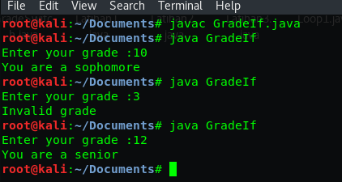

1. **Using switch structure**

import java.util.Scanner;

public class GradeSwitch{

public static void main(String[]args){

Scanner in= new Scanner(System.in);

System.out.println("Enter your grade ?");

int grade= in.nextInt();

switch (grade){

case 9:

System.out.println("You aare freshman");

break;

case 10:

System.out.println("You are sophomore");

break;

case 11:

System.out.println("You are a junior");

break;

case 12:

System.out.println("You are a senior");

break;

default:

System.out.println("Invalid grade");

}

}

}

Output :

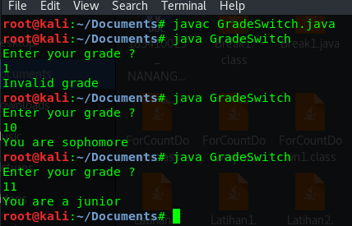

**2nd Practice**

1. **Int type**

import java.util.Scanner;

public class DaysMonth{

public static void main(String[]args){

Scanner in= new Scanner(System.in);

System.out.print("Enter your number of month: ");

int month= in.nextInt();

switch (month){

case 1: case 3: case 5: case 7:

case 8: case 10: case 12:

System.out.println("31 days in a month");

break;

case 2:

System.out.println("not leap year 28 days in the month");

System.out.println("leap year 29 days in the month");

break;

default:

System.out.println("30 days in a month");

}

}

}

Output :

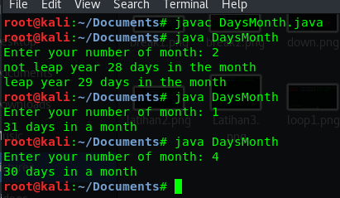

1. **String type**

public class TypeOfDay{

public static void main(String[]args){

String typeOfDay= "";

String dayOfWeekArg= "Thursday";

switch (dayOfWeekArg){

case "Monday":

typeOfDay= "Start of work week";

break;

case"Tuesday":

case "Wednesday":

case "Thursday":

typeOfDay= "Midweek";

break;

case "Friday":

typeOfDay= "End of work week";

break;

default:

System.out.println("Invalid");

}

System.out.println(typeOfDay);

}

}

Output :

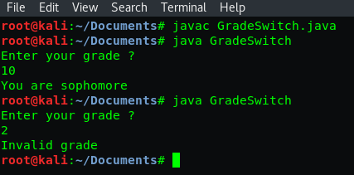

**3rd Practice**

1. **With break**

public class Break1{

public static void main(String[]args){

char option= 'A';

int aCount= 0, bCount= 0, cCount= 0;

switch (option){

case 'A':

aCount++;

System.out.println("Count of A" + aCount);

break;

case 'B':

bCount++;

System.out.println("Count of B" + bCount);

break;

case 'C':

cCount++;

System.out.println("Count of C" + cCount);

}

}

}

Output :

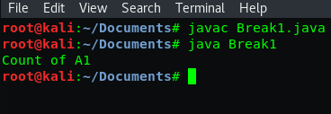

1. **Without break**

public class Break2{

public static void main(String[]args){

char option= 'A';

int aCount= 0, bCount= 0, cCount= 0;

switch (option){

case 'A':

aCount++;

System.out.println("Count of A" + aCount);

case 'B':

bCount++;

System.out.println("Count of B" + bCount);

case 'C':

cCount++;

System.out.println("Count of C" + cCount);

}

}

}

Output :

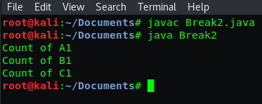

1. **Fall through**

public class FallThrough{

public static void main(String[]args){

int month= 12;

switch(month){

case 2:

System.out.println("28 days(29 in leap years)");

break;

case 4:

case 6:

case 9:

case 11:

System.out.println("30 days");

break;

case 1:

case 3:

case 5:

case 7:

case 8:

case 12:

System.out.println("31 days");

break;

default:

System.out.println("Illegal month number");

break;

}

}

}

Output :

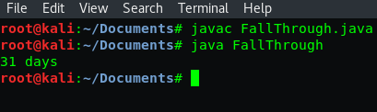

**4th Practice**

1. **Count down**

public class CountDown{

public static void main(String[]args){

System.out.println("CountDown to Launch");

System.out.println(10);

System.out.println(9);

System.out.println(8);

System.out.println(7);

System.out.println(6);

System.out.println(5);

System.out.println(4);

System.out.println(3);

System.out.println(2);

System.out.println(1);

System.out.println("Blast off!");

}

}

Output :

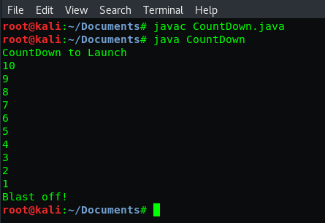

1. **Using help Variable**

public class CountDown1{

public static void main(String[]args){

int i= 10;

System.out.println("CountDown to Launch");

System.out.println(i);

i--;

System.out.println(i);

i--;

System.out.println(i);

i--;

System.out.println(i);

i--;

System.out.println(i);

i--;

System.out.println(i);

i--;

System.out.println(i);

i--;

System.out.println(i);

i--;

System.out.println(i);

i--;

System.out.println(i);

System.out.println("Blast off!");

}

}

Output :

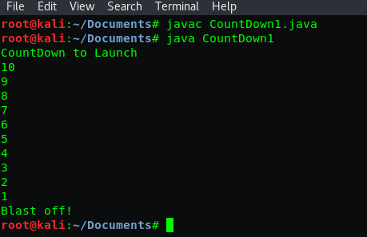

**5th Practice**

1. **Count down with for**

public class ForCountDown{

public static void main(String[]args){

System.out.println("CountDown");

for (int i=10;i>=0;i--){

System.out.println(i);

}

System.out.println("Blast off!");

}

}

Output :

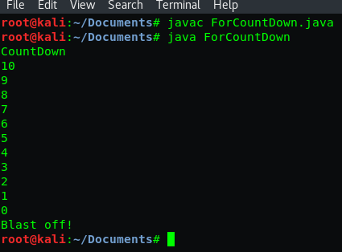

1. **Condition expression**

public class ForCountDown1{

public static void main(String[]args){

System.out.println("CountDown");

for (int i=10;i>0;i--){

System.out.println(i);

}

System.out.println("Blast off!");

}

}

Output :

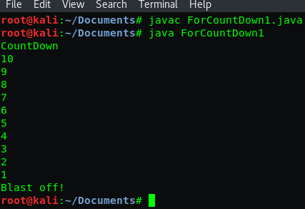

1. **Update expression**

public class ForCountDown2{

public static void main(String[]args){

System.out.println("CountDown");

for (int i=10;i>=0;i=i-2){

System.out.println(i);

}

System.out.println("Blast off!");

}

}

Output :

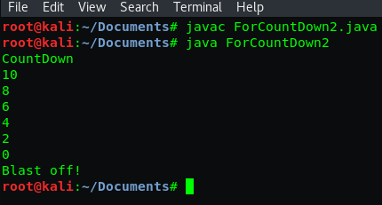

1. **Alternative update expression write**

public class ForCountDown3{

public static void main(String[]args){

System.out.println("CountDown");

for (int i=10;i>=0;){

System.out.println(i);

i--;

}

System.out.println("Blast off!");

}

}

Output :

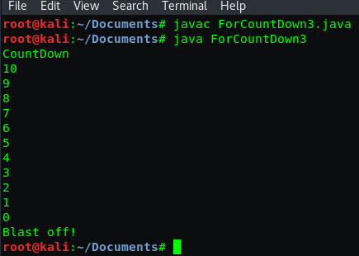

1. **Multiple statement**

public class Loop1{

public static void main(String[]args){

for (int i=5;i>0;i--)

System.out.println(i);

System.out.println("second line");

}

}

Output :

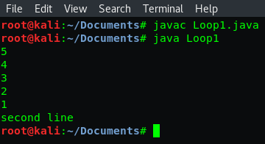

**6th Practice**

1. **Looping without loop**

public class Squared1{

public static void main(String[]args){

System.out.println("1 squared= " + 1*1);

System.out.println("2 squared= " + 2*2);

System.out.println("3 squared= " + 3*3);

System.out.println("4 squared= " + 4*4);

System.out.println("5 squared= " + 5*5);

}

}

Output :

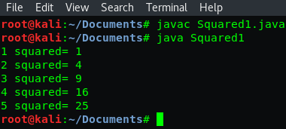

1. **looping with loop for**

public class Squared2{

public static void main(String[]args){

for (int i=0;i<=20;i+=2){

System.out.println(i);

}

}

}

Output :

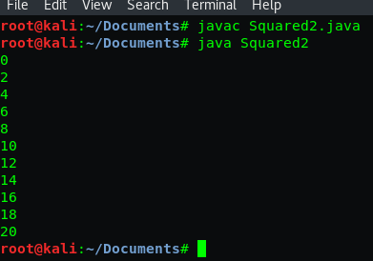

1. **Using I variable**

public class Squared3{

public static void main(String[]args){

for (int i=1;i<=5;i++){

System.out.println(i+" squared= "+ i*i);

System.out.println("i: "+i);

}

}

}

Output :

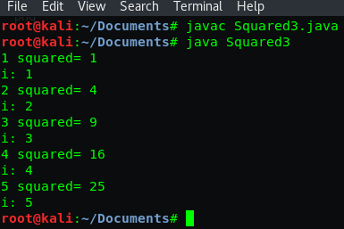

1. **Scope variable**

public class Scope1{

public static void main(String[]args){

int x= 0;

int i= 1;

for (int j=2;j<=5;j++){

System.out.println(j);

int k= 3;

System.out.println(x+i+j+k);

}

}

}

Output :

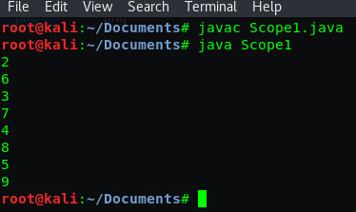

1. **Out of Scope**

public class Scope2{

public static void main(String[]args){

for (int j=0;j<=5;j++){

System.out.print(j+" ");

}

for (int j=5;j>=0;j--){

System.out.print(j+" ");

}

for (int k=2;k<=64;k=k+2){

System.out.print(k+" ");

}

}

}

Output :



**Exercise**

1. **Switch case**

import java.util.Scanner;

public class Latihan1{

public static void main(String[]args){

Scanner sc= new Scanner(System.in);

System.out.print("Masukkan nomor bulan : ");

int bulan= sc.nextInt();

switch(bulan){

case 1:

System.out.println("Januari");

break;

case 2:

System.out.println("Februari");

break;

case 3:

System.out.println("Maret");

break;

case 4:

System.out.println("April");

break;

case 5:

System.out.println("Mei");

break;

case 6:

System.out.println("Juni");

break;

case 7:

System.out.println("Juli");

break;

case 8:

System.out.println("Agustus");

break;

case 9:

System.out.println("September");

break;

case 10:

System.out.println("Oktober");

break;

case 11:

System.out.println("November");

break;

case 12:

System.out.println("Desember");

break;

default:

System.out.println("Invalid month");

}

}

}

Output :

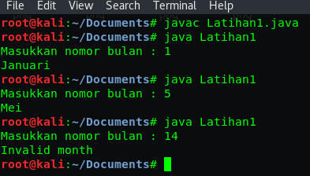

1. **Loop 0 till 5**

public class Latihan2{

public static void main(String[]args){

for(int i=0;i<=5;i++){

System.out.println(i);

}

}

}

Output :

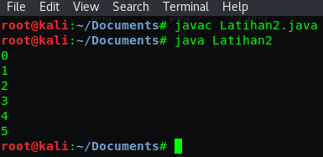

1. **Loop even 0 till 20**

public class Latihan3{

public static void main(String[]args){

for(int i=0;i<=20;i=i+2){

System.out.println(i);

}

}

}

Output :

